**The Learning Management System (LMS)**

**Technological Requirements: HTML, CSS, JAVASCRIPT, BOOTSTRAP, .NET, SQL SERVER, ASP.NET CORE, C#.**



**---------------------------------------------------------------------------------------------------------------------------**

* **System Purpose and Scope:**
* **Enhance learning experiences, streamline course management, and facilitate effective communication.**
* **What types of data will the system manage? (e.g., course content, student records, grades, assignments)**
* **Who are the main users of the system? (e.g., students, instructors, administrators)**
* 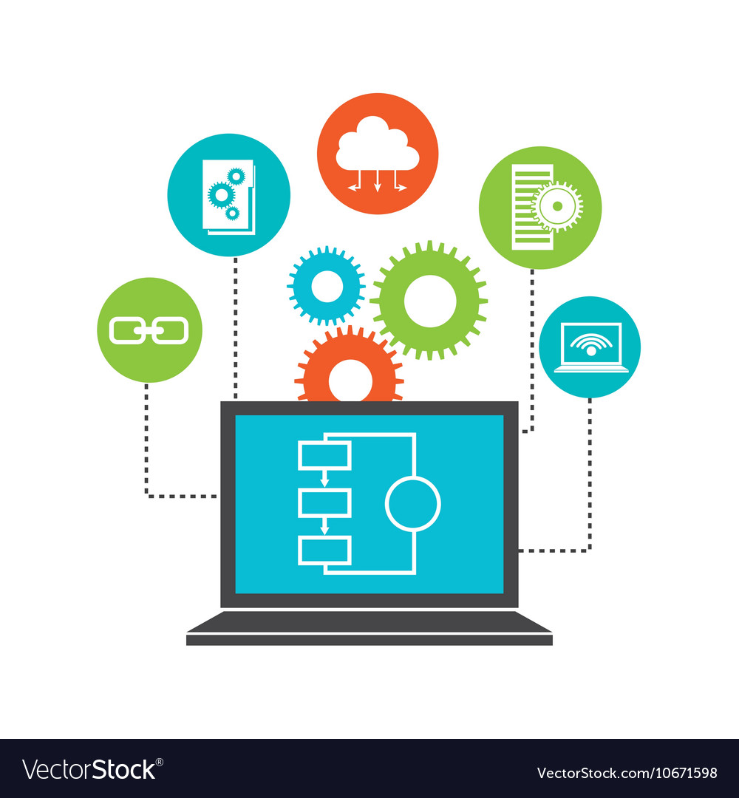 **Functional Requirements:**

1. **Data Management:**

* **Collect, Read, Retrieve, and Store course content, student records, grades, and assignments securely and efficiently.**
* **Facilitate data entry and updates by authorized users.**
* **Enable data search and filtering based on various criteria (e.g., course name, student ID, grade range).**
* **Implement robust data backup and disaster recovery procedures to ensure data integrity and availability.**

1. **Learning Support:** 
   * **Provide course management functionalities including course creation, editing, and deletion.**
   * **Facilitate communication and collaboration among students and instructors through discussion forums and messaging.**
   * **Allow for remote learning and assessments through online quizzes, assignments, and video lectures.**
2. **Administrative Functions:**

* **Manage user accounts and roles including students, instructors, and administrators.**
* **Facilitate course registration and enrollment processes for students.**
* **Generate reports for academic performance, attendance, and compliance with educational standards.**
* **Track learning materials and resources to ensure availability and proper usage.**
* **Non-Functional Requirements:**

1. **Performance:**

* **Faster Response and data access**
* **High Speed and Efficient to maintain the patient data**

1. **Cost:**

* **Development and Implementation cost only.**
* **Maintenance and data storage costs.**

1. **Usability:**

* **User-friendly interface with documentation of the application with sample demo.**
* **Application is accessible to all the actors based on their requirements or the content needed for that role.**

**Functional requirement with excel**